# Partial Hepatectomy, Regeneration & Liver function

Interesting & complex relationship between partial hepatectomy, regeneration and actual liver function.

Study in rats showed that liver functions are dissociated in time following 70% hepatectomy, and that GEC is restored before regeneration can compensate for the loss in liver cell mass {Yildrim1981}.

The rapid increase in the activities of the galactose metabolizing enzymes in vitro followin 70% hepatectoy {Bauer1976} led to the hypothesis that GEC *in vivo* is restored to normal due to an increased metabolizing capacity of the surviving hepatocytes {Yildrim1981}.

In both clinical and experimental studies, a discrepancy has arisen between volumetric and functional regeneration, from which 2 contradictory theories have emerged. The first theory suggests that hepatocyte prolveration is promoted at the expense of liver function {Jochum2006}. The second theory postulates that hepatocellular function is enhanded after major PHx to compensate for reduced liver mass {Jansen1990, Yildrim1981, } {Graaf2011}.

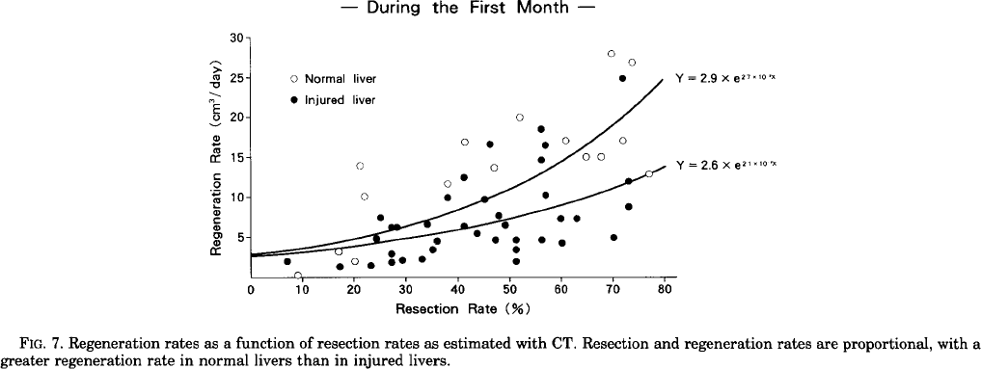

{Yamanaka1993}

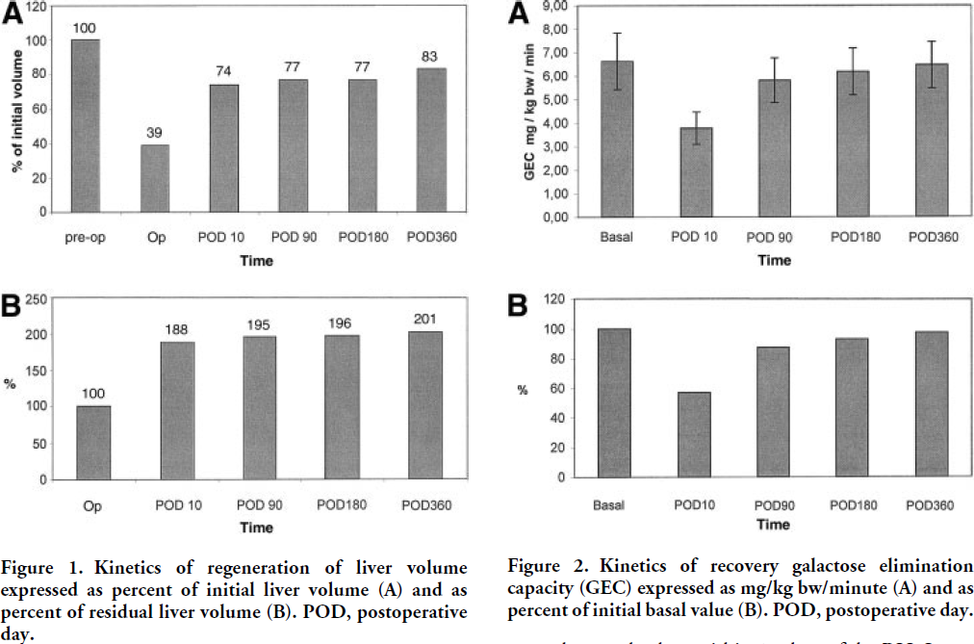{Nadalin2004}

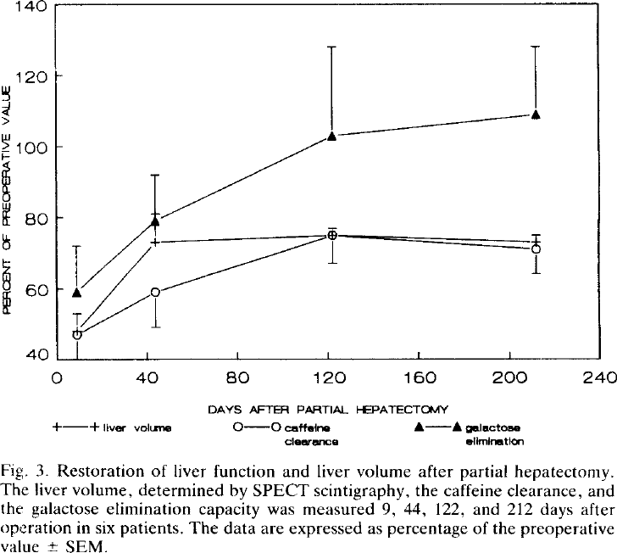{Jansen1990}

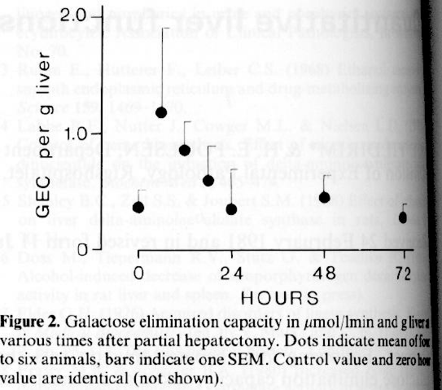{Yildrim1981}

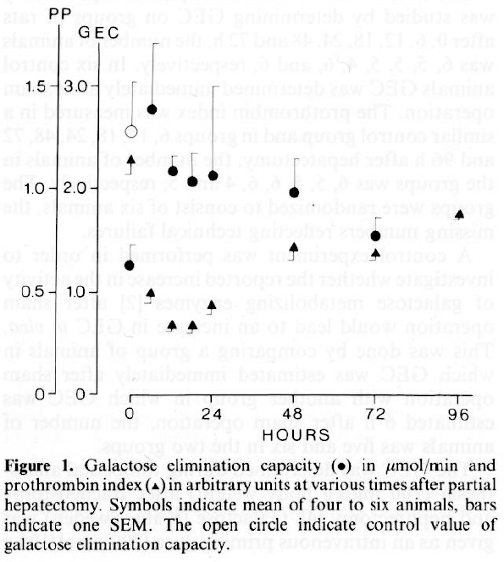{Yildrim1981}

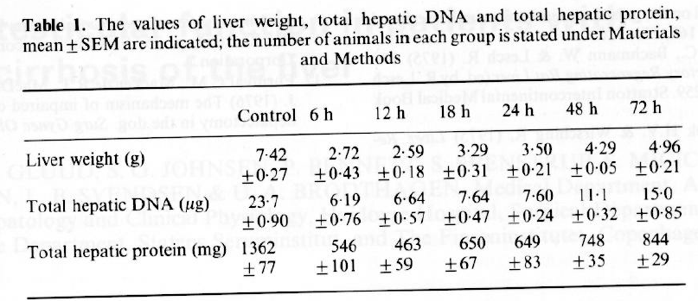{Yildrim1981}

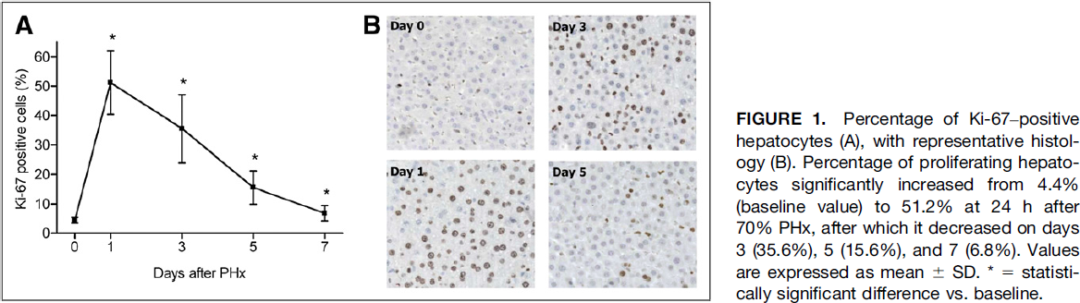{Graaf2011}

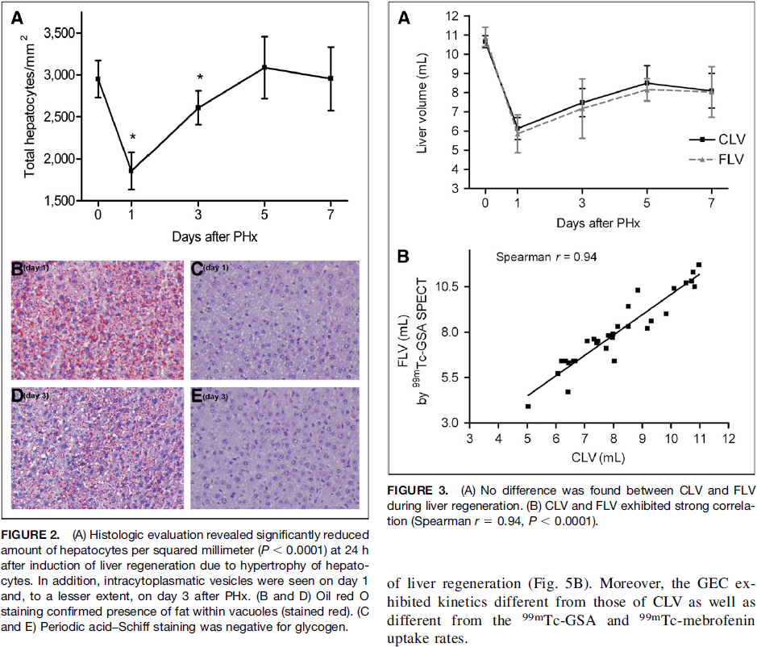{Graaf2011}

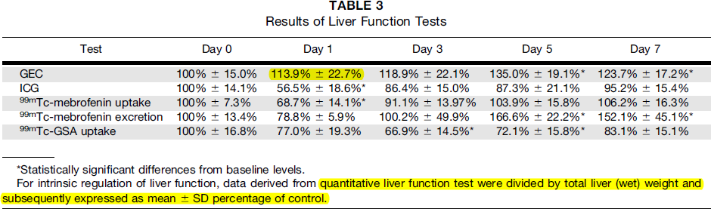

{Graaf2011}

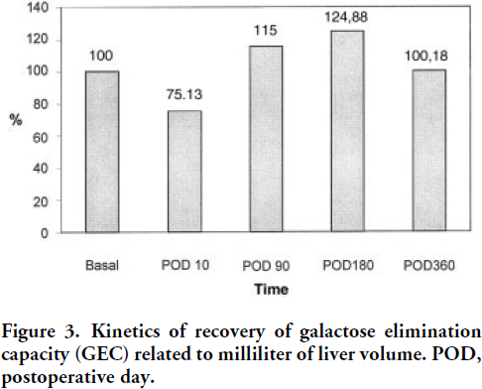{Nadalin2004}

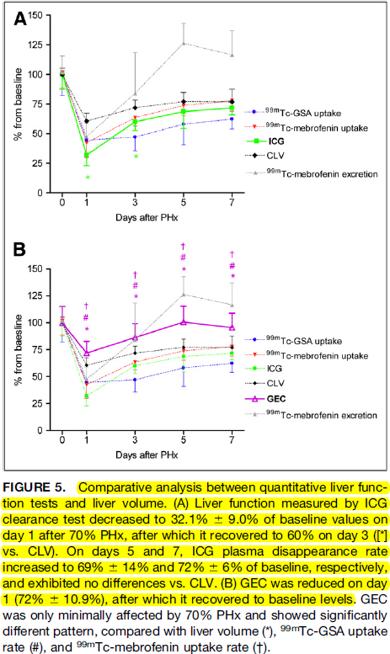{Graaf2011}

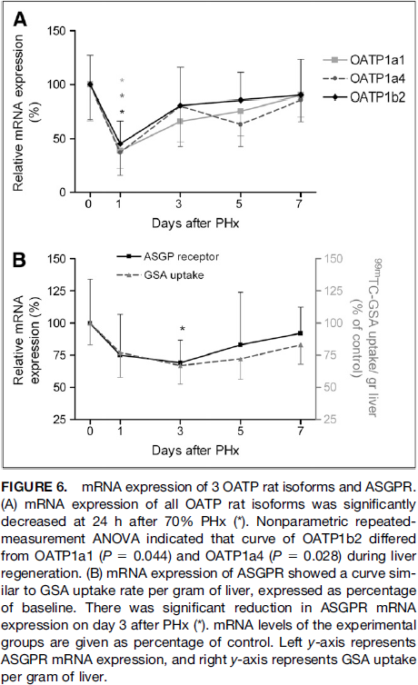{Graaf2011}

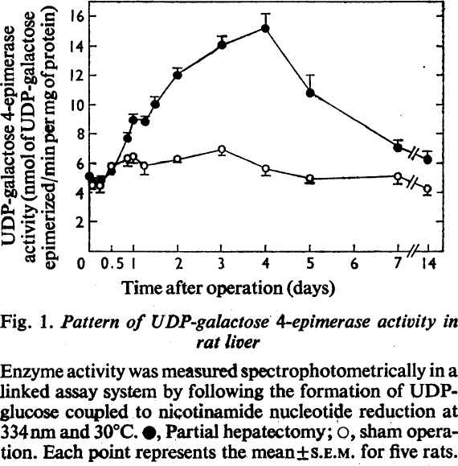{Bauer1976}

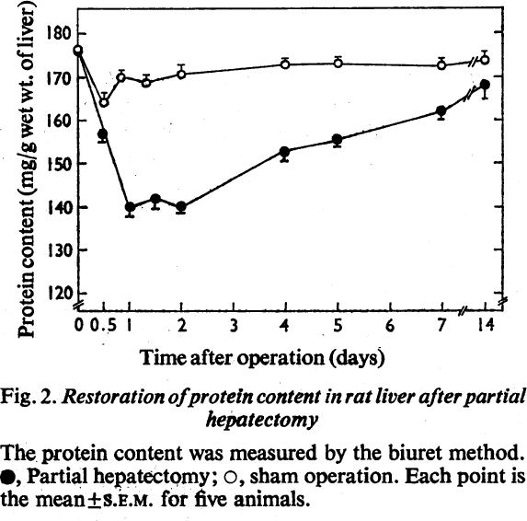{Bauer1976}

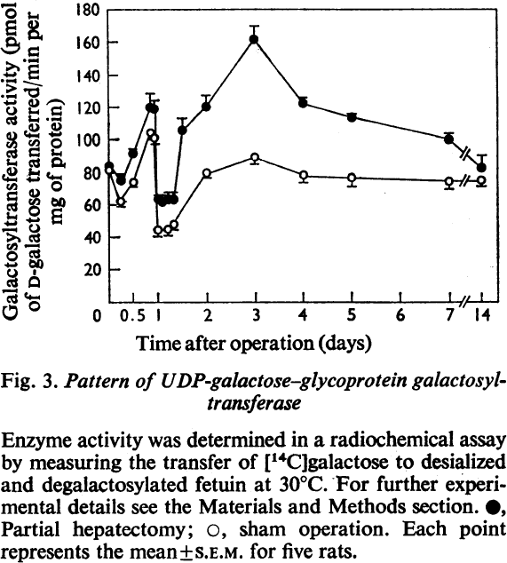{Bauer1976}

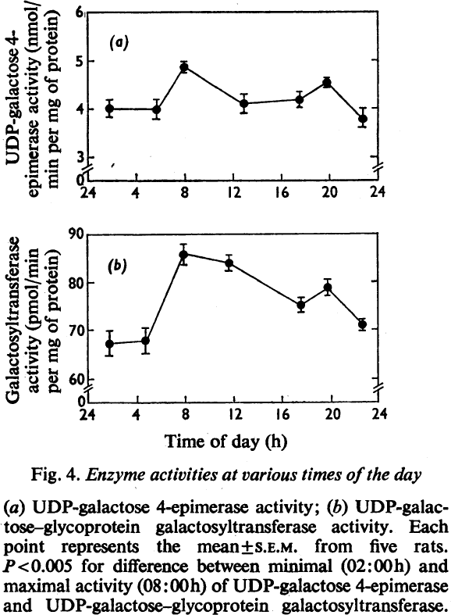{Bauer1976}

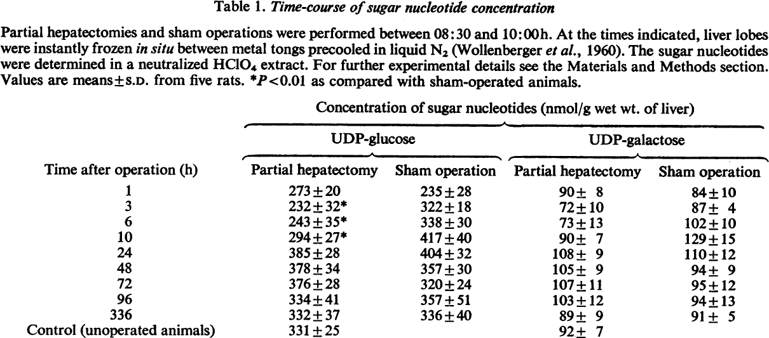

{Bauer1976}

## References

Bauer, CHRISTIAN H, BARBARA F Hassels, and WERNER G Reutter. "Galactose metabolism in regenerating rat liver." *Biochem. J* 154 (1976): 141-147.

de Graaf, W., Bennink, R. J., Heger, M., Maas, A., de Bruin, K., & van Gulik, T. M. (2011). Quantitative assessment of hepatic function during liver regeneration in a standardized rat model. *Journal of Nuclear Medicine*, *52*(2), 294-302.

Jansen, P., Chamuleau, R., Van Leeuwen, D., Schipper, H., Busemann-Sokole, E., & Heyde, M. v. d. (1990). Liver regeneration and restoration of liver function after partial hepatectomy in patients with liver tumors. *Scandinavian journal of gastroenterology*, *25*(2), 112-118.

Jochum, C., Beste, M., Penndorf, V., Farahani, M. S., Testa, G., Nadalin, S., et al. (2006). Quantitative liver function tests in donors and recipients of living donor liver transplantation. *Liver transplantation*, *12*(4), 544-549.

Kobayashi, T., Imamura, H., Aoki, T., Sugawara, Y., Kokudo, N., & Makuuchi, M. (2005). Morphological regeneration and hepatic functional mass after right hemihepatectomy. *Digestive surgery*, *23*(1-2), 44-50.

Nadalin, S., Testa, G., Malagó, M., Beste, M., Frilling, A., Schroeder, T., et al. (2004). Volumetric and functional recovery of the liver after right hepatectomy for living donation. *Liver transplantation*, *10*(8), 1024-1029.

Yamanaka, N., Okamoto, E., Kawamura, E., Kato, T., Oriyama, T., Fujimoto, J., et al. (1993). Dynamics of normal and injured human liver regeneration after hepatectomy as assessed on the basis of computed tomography and liver function. *Hepatology*, *18*(1), 79-85.

Yildirim, SI, and HE Poulsen. "Quantitative liver functions after 70% hepatectomy." *European journal of clinical investigation* 11.6 (1981): 469-472.